**Practical 1 --- First Android Application**

**Before start:**

Before you start with your **FIRST Android application**, you should make sure the following requirements fulfilled:

1. **Android SDK** installed
2. **Emulator created**

**Android SDK Manager**

The Android SDK Manager allows you to install the specific versions of Android API.

SDK Manager

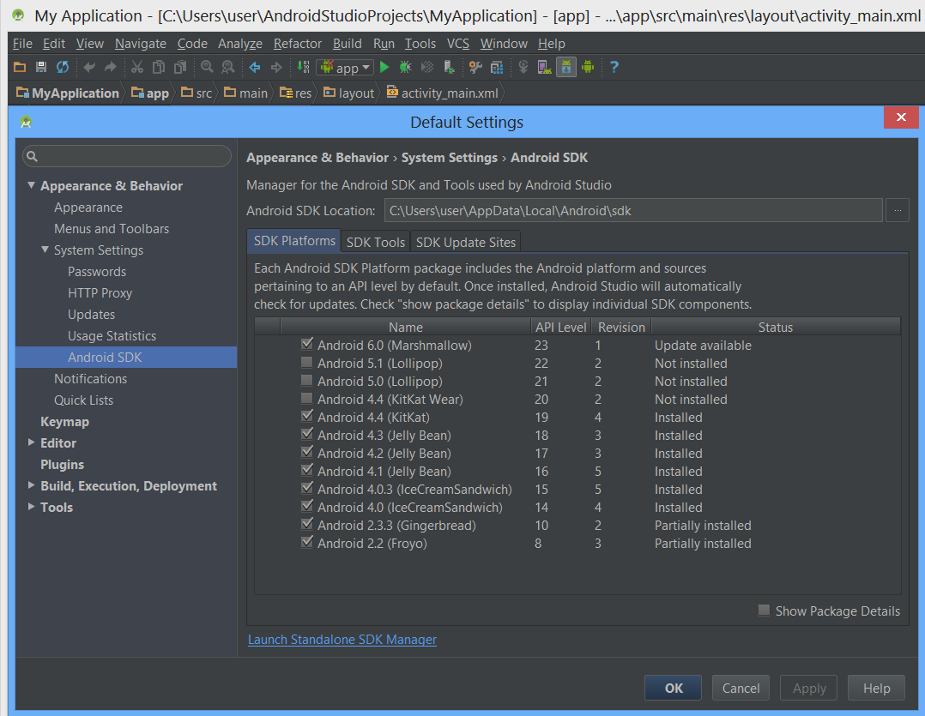

You should make sure that the entire needed API and support library for your APP development is installed.

Step to create your **FIRST ANDROID APPLICATION**

1. Click **NEW** in toolbar
2. In the window, click on the **Android folder** and select **Android Application Project** and click **NEXT**
3. In the form that appear, fill in the necessary parts:
   1. **Application Name**
   2. **Project Name**
   3. **Package Name**
   4. **Minimum Required SDK**

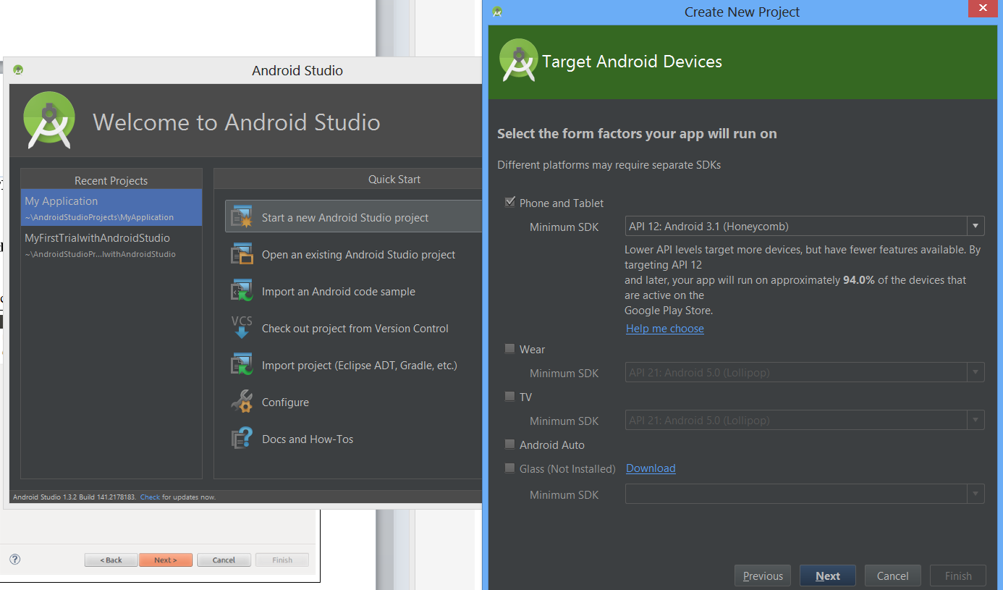

1. You may then select an activity template from which to begin building your app. For this project, select **BlankActivity** and click **NEXT**.
2. Leave all the details for activity in their default state and click **Finish**.

**Setting up EMULATOR**

1. In order to run your application on **EMULATOR**, you should create an **ANDROID VIRTUAL DEVICE(AVD)**. An AVD is a device configuration for Android emulator that allows you to model different devices.

**To create AVD:**

1. In Android Studio, click **Android Virtual Device Manager**  from toolbar.
2. Click **CREATE VIRTUAL DEVICE** in the Android Virtual Device Manager panel.
3. Fill in the details for the AVD, choose the phone model, API level, processor type (choose armeabi-v7a), scale, orientation, and other hardware specification such as RAM, SD-Card and etc.
4. Clicks CREATE **AVD**.
5. Select the **NEW AVD** from the Android Virtual Device Manager and click **START**.

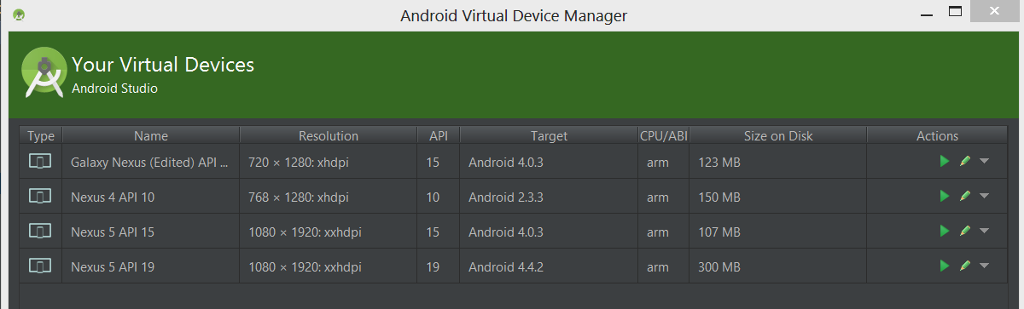

Click to launch the Emulator

1. Once the Emulator launched, you can click ALT + Space and choose the **MOVE** option and further use the ARROW key to navigate the Emulator.

**Run your APP**

1. Open your project’s files and click **RUN** from toolbar.
2. In the **RUN** window that appears, select **ANDROID APPLICATION** and click **OK**.

**Java Exercise**

1. Create two classes, A and B, with default constructors (empty argument lists) that announce themselves. Inherit a new class called C from A, and create a member of class B inside C. Do not create a constructor for C. Create an object of class C and observe the results.
2. Create a class called Amphibian. From this, inherit a class called Frog. Put appropriate methods in the base class. In main( ), create a Frog and upcast it to Amphibian, and demonstrate that all the methods still work.
3. Create an inheritance hierarchy of Rodent: Mouse, Gerbil, Hamster, etc. In the base class, provide methods that are common to all Rodents, and override these in the derived classes to perform different behaviors depending on the specific type of Rodent. Create an array of Rodent, fill it with different specific types of Rodents, and call your base-class methods to see what happens.
4. Create three interfaces, each with two methods. Inherit a new interface from the three, adding a new method. Create a class by implementing the new interface and also inheriting from a concrete class. Now write four methods, each of which takes one of the four interfaces as an argument. In main( ), create an object of your class and pass it to each of the methods.